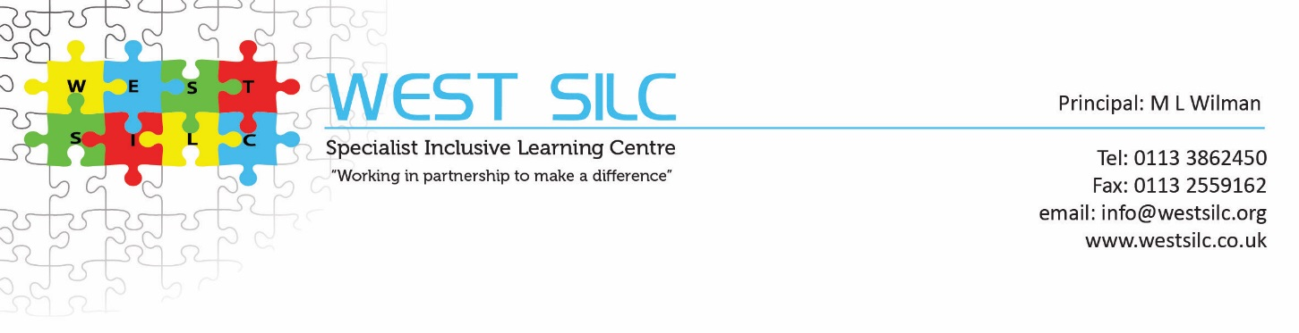
UNIFORM ORDER FORM
Maroon Sweatshirts – Crew Neck
Ages: 2, 3/4, 5/6, 7/8, 9/10, 11/12 or 13 | £8.95 each
Adults: Small, Medium, Large, Extra Large, Extra Extra Large | £11.25 each
Maroon Cardigans
Cotton Rich:  Ages: 2, 3/4, 5/6, 7/8, 9/10, 11/12, 13 | £9.75 each
Adults: Small, Medium, Large, Extra Large, Extra Extra Large | £12.40 each
Polo Shirts – Standard Weight in White or Light Blue Only
Ages: 2, 3/4, 5/6, 7/8, 9/10, 11/12, 13 | £6.10 each
Adults: Small, Medium, Large, Extra Large, Extra Extra Large | £7.60 each
Polo Shirts – Heavy Weight in Maroon Only
Ages: 2, 3/4, 5/6, 7/8, 9/10, 11/12, 13 | £7.50 each
Adults: Small, Medium, Large, Extra Large, Extra Extra Large | £9.20 each

WEST SILC – UNIFORM ORDER
** Please specify number and size required and return to the main site school office with payment – please make cheques payable to West SILC Fund **

NAME OF CHILD…………………………………………………………………. SITE: …………………………………………………
Item | Colour | Size | Quantity Required | Cost
Sweatshirt – Crew Neck | Maroon only
Cardigans | Maroon only
Polo Shirts – Standard
Weight
Polo Shirts – Heavy Weight | Maroon only
 |  | TOTAL COST |  | £

